A Project Report

On

**SMART WATCHES IN HEALTHCARE**

BY

THRIVIKRAM KATARI-SE20UECE096

KAUNDINYA SWARNA-SE20UECE034

KRISHNA SWAMY KOTA-SE20UECE037

LIKITHA SAI KARANAM-SE20UEEE015

Under the supervision of

**ANKITA JAIN**

**SUBMITTED IN PARTIAL FULLFILLMENT OF THE REQUIREMENTS OF**

**PR 301: PROJECT TYPE COURSE**

cid:image003.png@01D6594A.2604D070

**ECOLE CENTRALE SCHOOL OF ENGINEERING**

**HYDERABAD**

**(JUNE 2023**)

ACKNOWLEDGMENTS

**We would like to thank our supervisor, Dr. Ankita Jain , for her expertise, guidance, and continuous support throughout this project. Your insights and feedback have greatly contributed to the quality and success of this research.**

**We would like to express our appreciation to our colleagues and friends who have supported us throughout this project. Their encouragement, discussions, and assistance have been invaluable in overcoming challenges and keeping us motivated.**

**We would also like to thank the numerous research professionals in this field whose research papers and online articles greatly contributed to our knowledge on this subject and helped us understand many difficult topics.**

cid:image003.png@01D6594A.2604D070

**Ecole Centrale School of Engineering**

**Hyderabad**

Certificate

This is to certify that the project report entitled “SMART WATCHES IN HEALTH CARE**”**

Submitted by Mr.THRIVIKRAM KATARI(HT No. SE20UECE096),KRISHNA SWAMY KOTA

(HT NO.SE20UECE037),KAUNDINYA SWARNA(HT NO.SE20UECE034),LIKITHASAI

KARANAM(HT NO.SE20UEEE015) in partial fulfillment of the requirements Of the course PR301

Project Course, embodies the work done by him/her under my supervision and

guidance.

**(SUPERVISOR NAME & Signature)**

**Ankita Jain**

Ecole Centrale School of Engineering, Hyderabad.

Date: 16-06-2023

ABSTRACT

The aim of this project is to explore usage of smartwatches in the field of healthcare.

Analyse the data acquired from built-in sensors of the smartwatches to monitor the health

of the user.We from Mahindra university of Electronics department students.

Collected data from accelerometer and gyroscope sensor of a smart watch.

The data set contains the low level time series sensor data from the watches accelerometer and

Watches gyroscope.All of the time-series data is tagged not only with the activity that was being

performed ,but with a subject identifier,which means the data be used for building and evaluate

biometric models as well recognition models.

CONTENTS

Title page………………………………………………………… …….1

Acknowledgement……………………………………………………..2

Certificate…………………………………………………………….....3

Abstract………………………………………………………………....4

1.Introduction……………………………………………….……… ….....6

2.Implementation……………………………………………………………..7

Conclusion……………………………………………………………..9

**INTRODUCTION**

In recent years, smartwatches have emerged as powerful and versatile devices, offering a multitude of features beyond their traditional timekeeping function. As technology continues to advance, these wearable devices have found their way into various aspects of our lives, including the healthcare sector. The integration of smartwatches into healthcare practices has shown great promise, with the potential to enhance patient monitoring, promote preventive care, and improve overall well-being.

Smartwatches equipped with sensors and advanced technology have transcended the traditional notion of timekeeping. They now provide users with a range of health-related functionalities, such as heart rate monitoring, sleep tracking, activity tracking, and even electrocardiogram (ECG) readings. These features allow individuals to gain real-time insights into their health and make informed decisions about their lifestyle choices.

However , our project focuses on implementing several Machine Learning algorithms on raw smartwatch sensor data to identify and classify daily-life human activities like Walking, Running, Eating , Drinking , Climbing upstairs/downstairs etc. We decided to use a simple approach as we were dealing with a large dataset with over 15 million data points and almost a hundred features to choose from , to avoid complexities and to learn whatever we could on our endeavour

**IMPLEMENTATION OF PROJECT**

The dataset was obtained from the WISDM UCI repository, specifically focusing on smartwatch data. The dataset comprises accelerometer and gyroscope sensor readings from 50 patients, resulting in a total of 100 patient datasets.

1. The first thing is importing all the libraries into the jupyter.
2. Reading all the raw data files and data cleaning is done like removing all the null values and duplicate values.
3. Now, plotting the data as per the activity like for the given activity is depicted towards x-axis and corresponding number of smaples (count) is depicted on y-axis.
4. Splitting the data into 2 parts one is the training data and other one is testing the data. The training data will be of 80% of whole data and the testing data is of 20% .
5. And from the original data we’re trying to import all the statistical features like Mean, std deviation, Median absolute deviation(mad) , Maximum value, Minimum value, signal magnitude(sma), energy , Interquartile range(iqt), Correlation between axis(Cxy).
6. So, here basically we are importing these feautures for both training and testing data also. So for each feauture there is training and testing implementation.
7. This process is called the feature extraction.
8. After all the feature extraction is completed, Now we are assigning these features into the training labels and testing labels.
9. We are using the logistic regression to perform the classification. We are passing all the training data and fitting into a model.

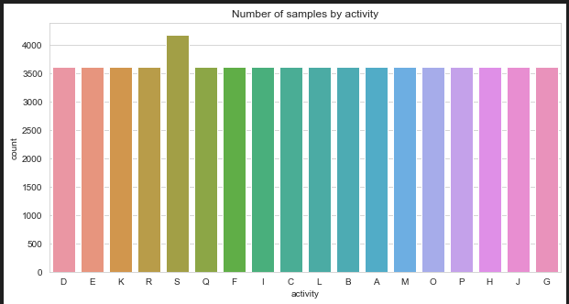

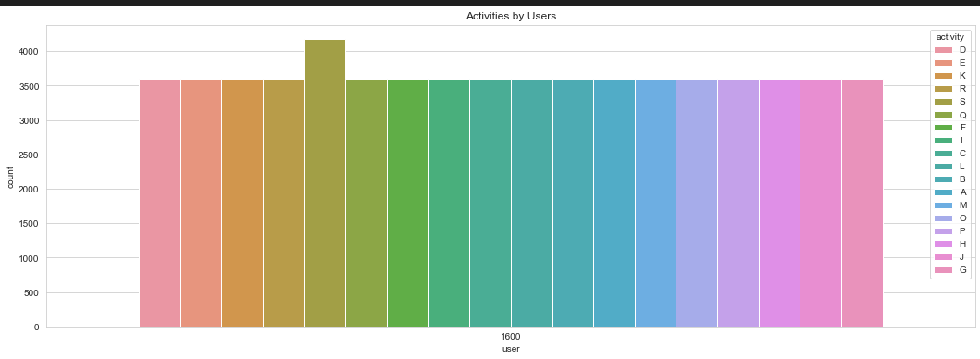 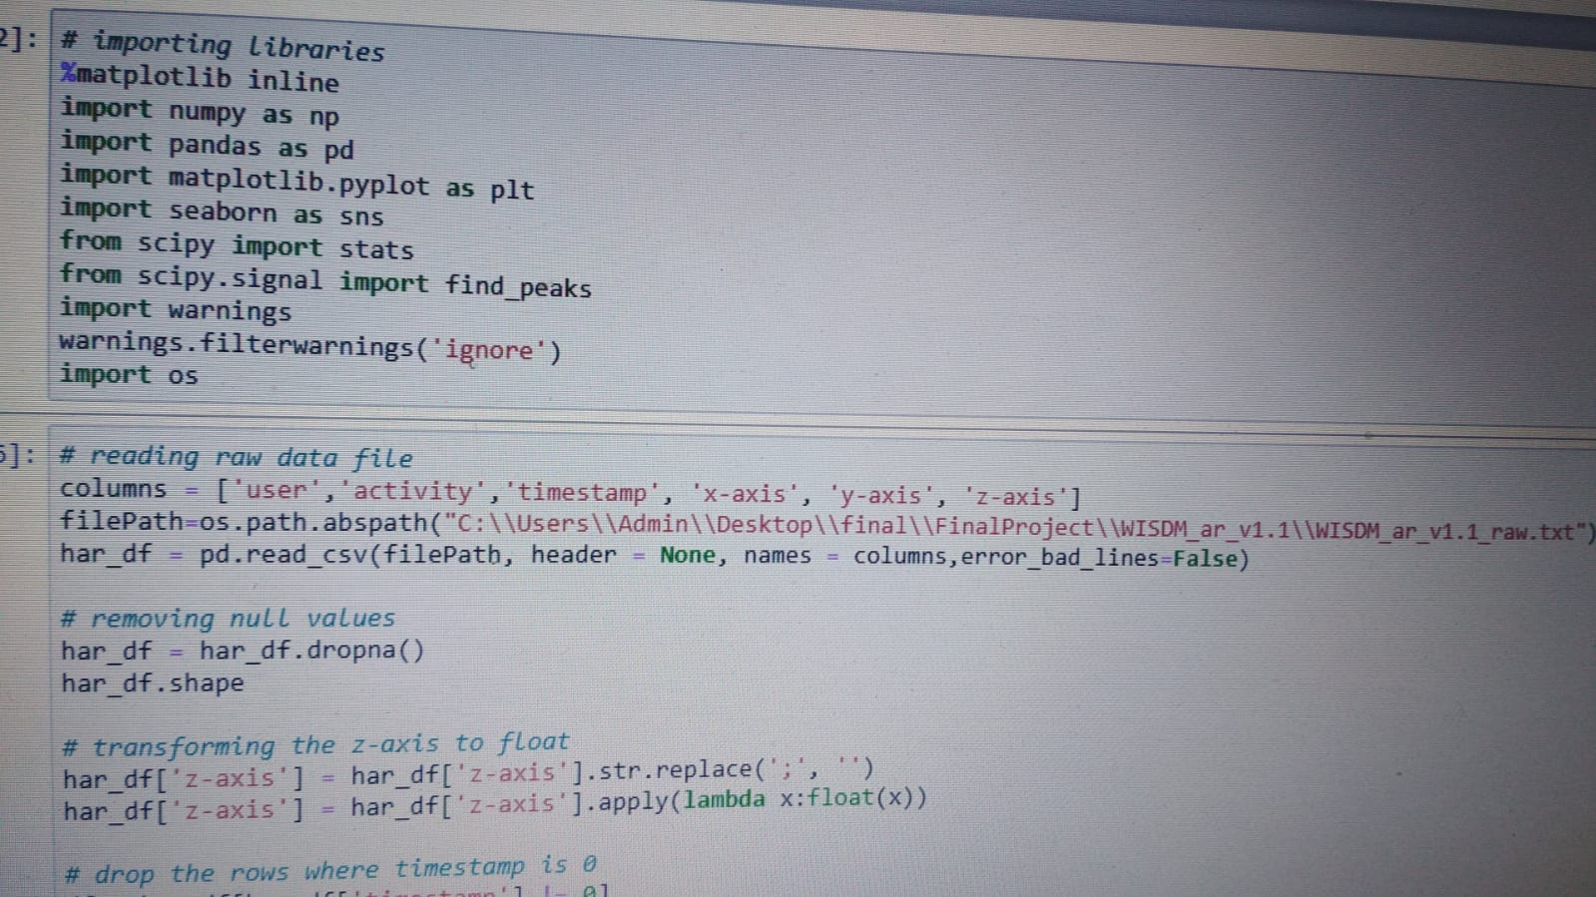

**RESULTS:**

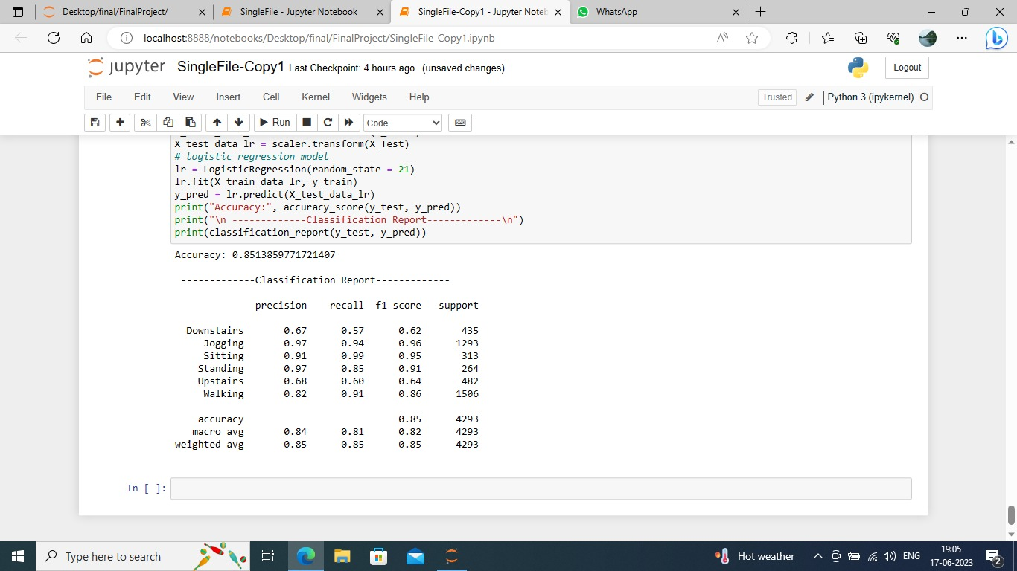

**CONCLUSION**

The smartwatch for healthcare project aimed to explore the potential benefits of integrating wearable technology into the field of healthcare. Through extensive research, development, and testing, the project has yielded several significant findings that demonstrate the positive impact of smartwatches on healthcare.

One of the key findings of this project is that smartwatches have the potential to revolutionize healthcare by providing real-time monitoring of various health parameters. The ability to continuously track vital signs, such as heart rate, blood pressure, and sleep patterns, offers healthcare professionals valuable insights into patients' well-being. This data can be used for early detection and prevention of potential health issues, leading to improved patient outcomes.

Moreover, the integration of smartwatches with healthcare systems enables remote patient monitoring, which has proven especially useful during the COVID-19 pandemic. By allowing healthcare providers to monitor patients from a distance, smartwatches have played a crucial role in minimizing the risk of exposure while ensuring continuous care.

Furthermore, the project has demonstrated the potential for smartwatches to enhance patient engagement and promote healthy lifestyles. Features like activity tracking, exercise reminders, and personalized health recommendations empower individuals to take control of their well-being. This proactive approach to healthcare encourages preventive measures and fosters a culture of self-care.

The successful implementation of the smartwatch for healthcare project signifies a significant advancement in the field. However, there are still areas for further exploration and improvement. For instance, the accuracy and reliability of sensor data need to be continually refined to ensure precise health monitoring. Additionally, expanding the range of health parameters that can be monitored by smartwatches would enhance their utility in diverse healthcare scenarios.

Looking ahead, future developments in smartwatch technology hold great promise for healthcare. As advancements in artificial intelligence and machine learning continue, smartwatches can become even smarter in analyzing health data and providing personalized insights. Integration with electronic health records and seamless data sharing between healthcare providers can further streamline patient care and enable comprehensive health management.

In conclusion, the smartwatch for healthcare project has demonstrated the immense potential of wearable technology in transforming healthcare. By providing real-time monitoring, remote patient care, and promoting healthy lifestyles, smartwatches have proven to be a valuable tool for healthcare professionals and individuals alike. With ongoing research and technological advancements, smartwatches will undoubtedly continue to play a pivotal role in shaping the future of healthcare.